Cremation

Direct Cremation prices from $2780-$6820
Includes service of staff, transfer to the funeral home from Waterloo/Cedar Falls, care of the body and sheltering of the remains when there is no embalming, and cremation charge. It DOES NOT include embalming, use of facilities or staff for viewing or ceremonies, or medical examiner’s permit.
A. Direct cremation with container provided by purchaser $2780
B. Direct cremation with alternative container $2850
C. Direct cremation with acceptable casket (casket additional) $2780
If you want to arrange a direct cremation you can use an alternative container. Alternative containers encase the body and can be made of materials like fiberboard or composition materials (with or without an outside covering). The containers we provide are constructed of cardboard.

Basic Cremation $3155
Includes services of funeral director and staff, removal from place of death within 30 mile radius of our facility, private one hour family viewing during normal business hours, cremation, and filing of necessary paperwork.

Funeral Service with Visitation and Cremation $4995
Traditional funeral with embalming, use of facilities, equipment and staff for visitation and funeral ceremony at our location or transfer and set up at another location. Includes use of hearse.

Direct Cremation (B) with Gathering and Memorial Service $3875
This option includes Direct Cremation (B) service with the use of facilities or transfer to another location, equipment and staff for gathering and memorial service.

Direct Cremation (B) with Memorial Service $3400
This option includes Direct Cremation (B) service with the use of facilities or transfer to another location, equipment and staff for memorial service.

Direct Cremation (B) with Gathering $3325
This option includes Direct Cremation (B) service with the use of facility, equipment and staff for gathering time.

Merchandise

Itemized pricing lists are available upon request

Caskets $950-$13995
A complete price list will be provided at the funeral home

Outer Burial Containers $725-$11095
A complete price list will be provided at the funeral home

Cremation Containers $70-$4265
A complete price list will be provided at the funeral home

Cremation Urns $40-$1895
A complete price list will be provided at the funeral home

Cremation Urn Vaults $475-$1080
A complete price list will be provided at the funeral home

Printed Materials and Accessories
Memorial Package $225
The Memorial Package includes one register book; up to 300 stock service folders; and stock acknowledgement cards.
(For custom service folders or acknowledgement cards add $50)

The following items may be purchased separately
Register Book $50

Stock Service Folders (per 100) $125

Custom Service Folders up to 3 pictures (per 100) $150

Prayer Cards (per 100) $35

Stock Acknowledgement Cards (box of 25) $7.50

Custom Acknowledgement Cards/Envelopes (box of 25) $10

Crucifix $25

Temporary Grave Marker $50

Richardson Funeral and Cremation Service makes no warranties or representation concerning the products sold herein. The only warranties, expressed or implied, granted in connection with the products sold with this funeral service, are the expressed written warranties, if any, extended by the manufacturers thereof. Richardson Funeral and Cremation Service hereby expressly disclaims all warranties, expressed or implied, relating to all such products, including, but not limited to, the implied warranties of merchantability and fitness for a particular purpose.

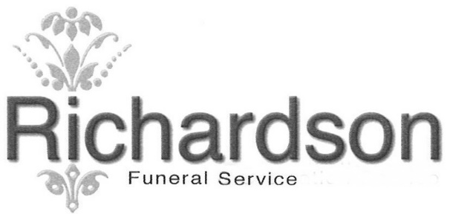
615 Main Street wP.O. Box 542 wCedar Falls, Iowa 50613
Phone: (319) 266-3525
Website: www.richardsonfuneralservice.com
Email: richardsonfuneralservice@gmail.com
Michael J. Sulentic w Paul H. Van Gorp w Donald J. Richardson

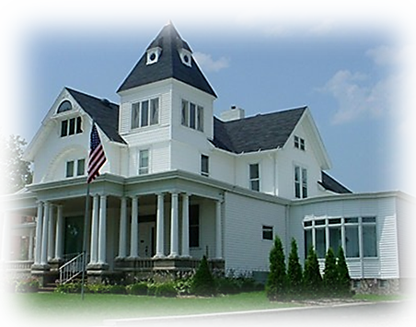

General Price List

These prices are effective January 1, 2022
But subject to change without notice.

Itemized Selections
The goods and services shown below are those we can provide to our customers. You may choose only the items you desire. However, any funeral arrangements you select will include a charge for our basic services and overhead. If legal or other requirements mean you must buy any items you did not specifically ask for, we will explain the reason in writing on the statement we provide describing the funeral goods and services you selected.

Professional Services
1. *Basic Services of Funeral Director and Staff $2730
Our fee for the basic services of funeral directors and staff includes, but is not limited to, staff to respond to initial request for service, arrangement conference, arrangement for ceremonies, preparation and filing of necessary authorizations and permits, recording vital statistics, preparation and placement of obituary notices, and coordination with others providing services. Also included in this charge are operation costs relative to our facilities, professional licensing, legal and accounting, insurance, utilities, maintenance, taxes, equipment, automotive, furnishings, inventory costs and administrative expense. This fee for our basic services will be added to the total cost of the funeral arrangements you select. (This fee for our basic services and overhead is already included in our charges for direct cremation, immediate burial, deed to medical science and forwarding or receiving of remains.)

2. *Embalming $950
Except in certain special cases, embalming is not required by law. Embalming may be necessary, however, if you select certain funeral arrangements, such as a funeral with a viewing. If you do not want embalming, you usually have the right to choose an arrangement that doesn’t require you to pay for it, such as direct cremation or immediate burial.

3. *Other Preparation of the Deceased $325
This includes cosmetology, dressing and casketing of the deceased or sanitizing, posing and other care of the deceased.
A. Restorative Care Following Autopsy $50
B. Restorative Care Following Organ Donation $100
Facilities
4. *Facilities, Equipment and Staff for Viewing, Visitation or
Gathering (per day) $475
Our service includes set-up and use of visitation/viewing area, placement of casket, urn or personal items, use of equipment, arrangement of floral offerings, direction of visitors and general supervision.
A. Viewing prior to service (2 hours or less) $200
B. Private family viewing $100

5. *Facilities and Staff for Funeral Ceremony $550
Our service includes use of facilities and/or transfer to another location, necessary equipment, staff coordination, arrangement of floral offerings and distribution of floral offerings following ceremony (maximum of three (3) locations).

6. Facilities and Staff for Memorial Ceremony $550
Our service includes use of facilities and/or transfer to another location, necessary equipment, staff coordination, arrangement of floral offerings and distribution of floral offerings following ceremony (maximum of three (3) locations).

7. *Staff and Equipment for Graveside Service $350
Our service includes staff to coordinate the ceremony at the graveside and necessary equipment.

Automotive Equipment
Unless otherwise noted, all automotive charges are for within a 30 mile radius of our facility. A per vehicle charge of $2.25 per mile, one way, will be added beyond our service area.

8. *Transfer of Deceased to Our Facility from Waterloo/Cedar Falls $345

9. *Use of Hearse for Transportation to the Place of Disposition $245

10. Use of family car $115

11. Use of Casket Bearer Sedan $95
Full Service Funeral Package $4995
If you wish to select individual aspects of our service, you may do so from the above list. If not, we offer a complete funeral service package at a reduced fee. This package includes all items with an “*” in the above list, whether used or not. Additional services may be added. Choosing this package will total a $1070 discount of total services.

Forwarding of remains to another funeral home $2595
This charge includes:
*Basic services of funeral director and staff
*Transfer of deceased from place of death to our facility
*Embalming
*This charge does not include a shipping container

Receiving of remains from another funeral home $2450
This charge includes:
*Basic services of funeral director and staff
*Local transportation of deceased to place of disposition within 30-mile radius of
our facility.

Immediate burial prices from $2950 - $13345
This charge includes immediate burial without visitation or ceremony or embalming.
*Basic services of funeral director and staff
*Transfer of deceased from place of death within 30-mile radius of our facility
*Transportation of deceased to cemetery within 30-mile radius of our facility.
A. Immediate burial with casket provided by purchaser $2950.00
B. Immediate burial with casket selected (casket price not included) $2950.00

Deed to Medical Science $2065.00
This charge includes basic services of funeral director and staff; transfer of deceased from place of death into our care, within 30-mile radius of our facility. Transfer to Iowa City, Des Moines or Rochester is an additional mileage charge of $2.25 per mile/one way.

